Prime Number Series in Java

Objective
To generate and display prime numbers using Java.

Description
This project prints prime numbers either up to a limit or first N prime numbers.

Algorithm
1. Start from number 2.
2. Check divisibility.
3. If not divisible, it is prime.
4. Repeat until N primes are found.

Program:
import java.util.*;
public class primeseries{
public static void main(String[] args)
{
Scanner sc = new Scanner(System.in);
System.out.print("Enter number of terms: ");
int n = sc.nextInt();
int count = 0, num = 2;
while(count < n)
{
boolean isPrime = true;
for(int i = 2; i <= num/2; i++)
{
if(num % i == 0)
{
isPrime = false;
break;
}
}
if(isPrime)
{
System.out.print(num + " ");
count++;
}

num++;
}
}
}
Output:
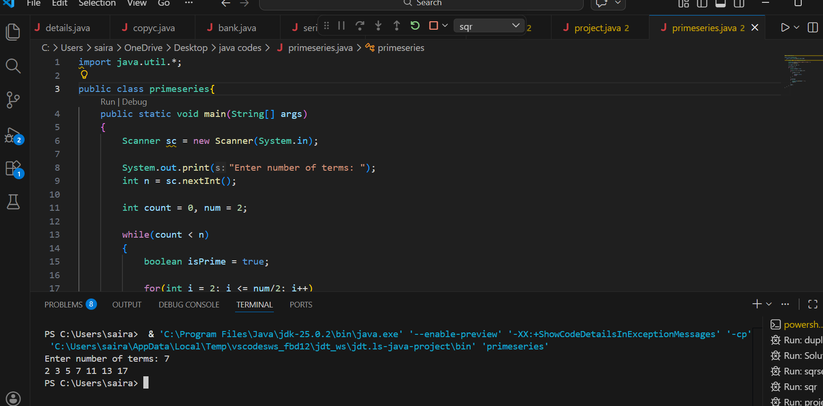

Conclusion
This project helps understand prime numbers and improves logical thinking.

